**DATA EXPLORATION REPORT**

**Machine Predictive Maintenance Classification**

**Hypothesis Formation**

Effect of Process Temperature on Failures –

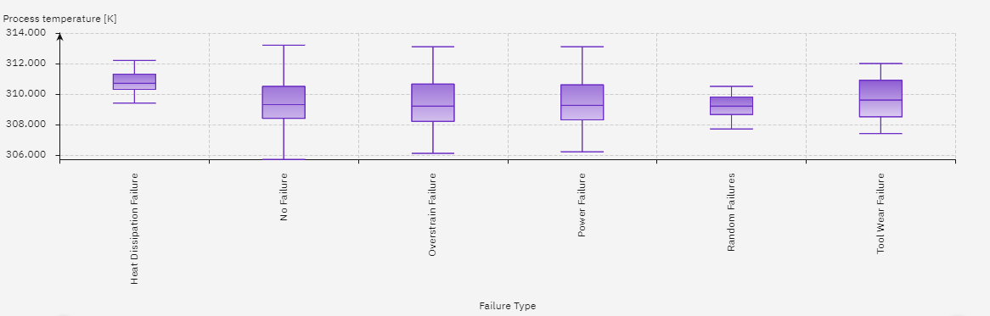

Conclusion – We can see that Power Failure , Overstrain Failure and Tool Wear failure occur in a very similar range of Process Temperature, hence we cannot decide on the basis of this. But we can distinguish between Heat Dissipation Failure and Random Failures clearly.

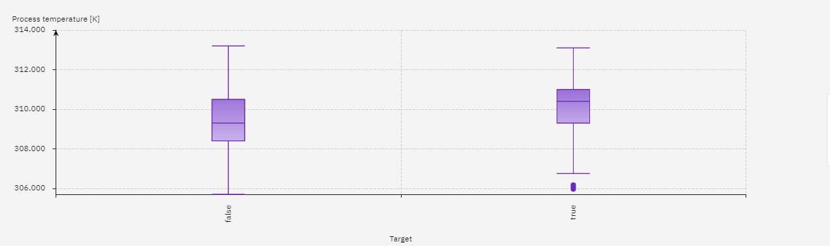

From the above graph , we can decide that there is a failure or not.

Effect of Tool Wear on Failure -

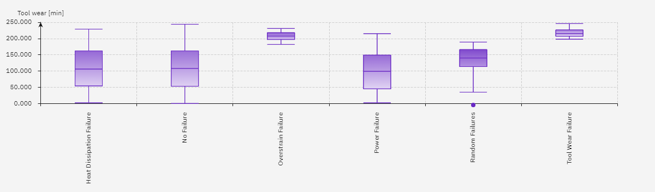

Conclusion – It is clearly evident that Overstrain Failure, Random Failures, Tool Wear Failure are extremely distinguishable as they occur in different range of Tool Wear . But Heat Dissipation and Power Failure have a common range of Tool Wear, hence we cannot decide on their basis.

Effect of Air Temperature on Failures –

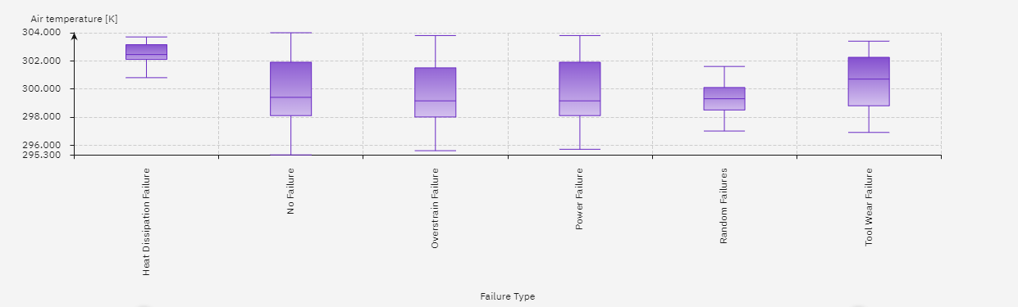

Conclusion – The air temperature range affecting Overstrain Failure and Power Failure is similar , but we can see that the range affecting Heat Dissipation Failure, Random Failure and Tool Failure is quite different. Therefore we can distinguish between the latter.

Effect of Rotational Speed on Failures –

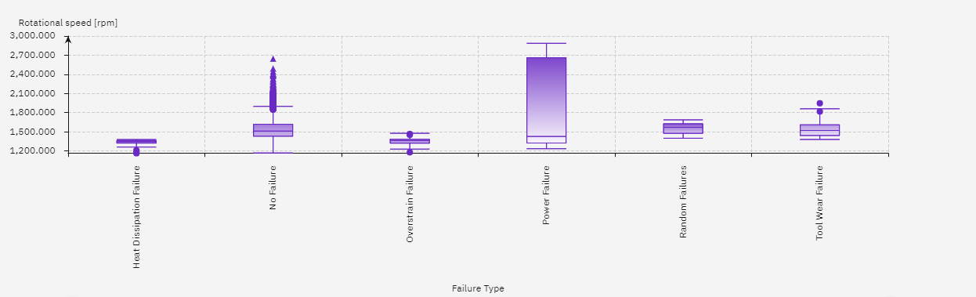

Conclusion – Since the range of rotational speed affecting the failures is very distinct , Hence this is the most effective attribute and we can distinguish between all the failures using this,

Effect of Torque on Failures –

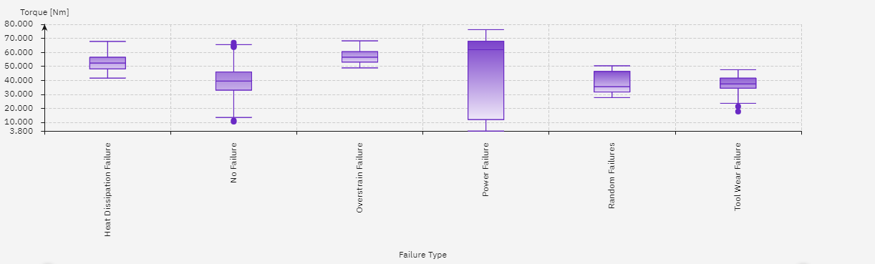

Conclusion – The range affecting the different failures is unique for each type. So this makes Torque an attribute of great importance . We can make decisions using this

Relationship between Torque and Rotational Speed –

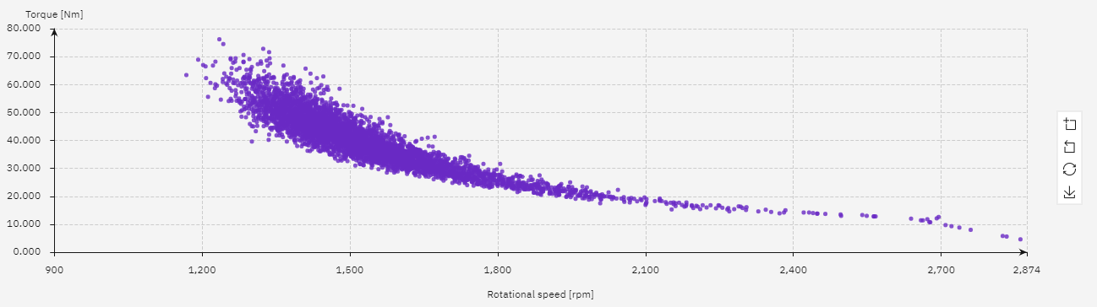

Conclusion – From the above graph we can clearly see that torque and rotational speed are inversely proportional to each other for a machine. Hence we can use any one of the two attribute for our decisions. The value of constant may change for different machines at same values.

Relationship between Type and Failure Type –

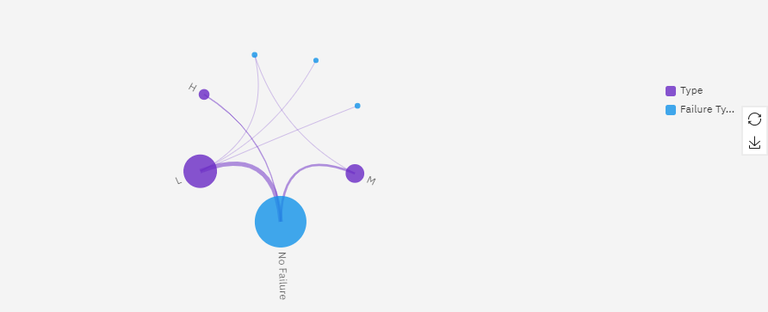

Conclusion – We see that Low Quality variants(L) are related to Power , Overtrain and Tool Wear failure and Medium Quality variants(M) is related to Power failure.

**Attributes Important For Further Analysis**

* Type
* Air temperature
* Rotational speed
* Tool wear

All these fields have a strong relationship with the failure type attribute , hence they are very important for further analysis.

**New Characteristics / Feature**



Yes ,we found out that torque and rotational speed are inversely proportional to each other using a scatter plot. From this information we can create a new feature from the above two attributes which can help in our further analysis

**How these explorations changed your initial hypothesis?**

No, the exploration did not change our initial hypothesis as they were already related to the machine failures.